Assignment 1
M.K.H.S. Gujarati Girls College, Indore
Name : Aayushi Sethi
Class : BCA V sem
Subject : Introduction to Data Science
Q.1. Explain what is data science and its process ?
Ans. Data science is the area of study which involves extracting insights from vast amounts of data by the use of various scientific methods, algorithms and processes. It helps you to discover hidden patterns from the raw data. The term data science has emerged because of the evolution of mathematical statistics, data analysis, and big data. Data science is an interdisciplinary field that allows you to extract knowledge from structured or unstructured data. Data science enables you to translate a business problem into a research project and then translate it back into a practical solution.
- Asking the right questions and exploring the data.
- Modelling the data using various algorithms.
- Finally visualizing the results.
Process of Data Science
- Frame the problem : Who is your client? What exactly is the client asking you to solve? How can you translate their ambiguous request into a concrete, well - defined problem ?
- Collect the raw data needed to solve the problem : Is this data already available? If so, what parts of the data are useful? If not, what more data do you need? What kind of resources (time, money, infrastructure) would it take to collect this data in a usable form?
- Process the data (data wrangling) : Real, raw data is rarely usable out of the box. There are errors in data collection, corrupt records, missing values and many other challenges you will have to manage. You will first need to clean the data to convert it to a form that you can further analyze.
- Explore the data : Once you have cleaned the data, you have to understand the information contained within at a high level. What kinds of obvious trends or correlations do you see in the data? What are the high-level characteristics and are any of them more significant than others?
- Perform in-depth analysis (machine learning, statistical models, algorithms) : This step is usually the meat of your project,where you apply all the cutting-edge machinery of data analysis to unearth high-value insights and predictions.
- Communicate results of the analysis : All the analysis and technical results that you come up with are of little value unless you can explain to your stakeholders what they mean, in a way that’s comprehensible and compelling. Data storytelling is a critical and underrated skill that you will build and use here.

Q.2. What are different types of data ? Explain in detail.
Ans. Data can be defined as a systematic record of a particular quantity. It is the different values of that quantity represented together in a set. It is a collection of facts and figures to be used for a specific purpose such as a survey or analysis. When arranged in an organized form, can be called information. The source of data ( primary data, secondary data) is also an important factor.

Types of Data

Primary Data
These are the data that are collected for the first time by an investigator for a specific purpose. Primary data are ‘pure’ in the sense that no statistical operations have been performed on them and they are original. An example of primary data is the Census of India.

Secondary Data
They are the data that are sourced from someplace that has originally collected it. This means that this kind of data has already been collected by some researchers or investigators in the past and is available either in published or unpublished form. This information is impure as statistical operations may have been performed on them already. An example is an information available on the Government of India, the Department of Finance’s website or in other repositories, books, journals, etc.
- Qualitative Data
They represent some characteristics or attributes. They depict descriptions that may be observed but cannot be computed or calculated. For example, data on attributes such as intelligence, honesty, wisdom, cleanliness, and creativity collected using the students of your class a sample would be classified as qualitative. They are more exploratory than conclusive in nature.
  - Quantitative Data
These can be measured and not simply observed. They can be numerically represented and calculations can be performed on them. For example, data on the number of students playing different sports from your class gives an estimate of how many of the total students play which sport. This information is numerical and can be classified as quantitative.
  - Discrete Data
These are data that can take only certain specific values rather than a range of values. For example, data on the blood group of a certain population or on their genders is termed as discrete data. A usual way to represent this is by using bar charts.
  - Continuous Data
These are data that can take values between a certain range with the highest and lowest value. The difference between the highest and lowest value is called the range of data. For example, the age of persons can take values even in decimals or so is the case of the height and weights of the students of your school. These are classified as continuous data. Continuous data can be tabulated in what is called a frequency distribution. They can be graphically represented using histograms.

Q.3. Explain various data-types in R ?
Ans.
Basic Data Types | Values
Numeric | Set of all real numbers
Integer | Set of all integers, Z
Logical | True and False
Complex | Set of complex numbers
Character | “a”, “b”, “c”, …, “@”, “#”, “$”, …., “1”, “2”, …etc

Numeric Data type
Decimal values are called numeric in R. It is the default data type for numbers in R. If you assign a decimal value to a variable x as follows, x will be of numeric type.
x = 5.6
print(class(x))
print(typeof(x))

Output:
[1] "numeric"
[1] "double"

Integer Data type
R supports integer data types which are the set of all integers. You can create as well as convert a value into an integer type using the as.integer() function. You can also use the capital ‘L’ notation as a suffix to denote that a particular value is of the integer data type.
x = as.integer(5)
print(class(x)) # print the class name of x
print( typeof(x)) # print the type of x
y = 5L # Declare an integer by appending an L suffix.
print(class(y)) # print the class name of y
print(typeof(y)) # print the type of y

Output:
[1] "integer"
[1] "integer"
[1] "integer"
[1] "integer"

Logical Data type
R has logical data types that take either a value of true or false. A logical value is often created via a comparison between variables.
x = 4
y = 3
z = x > y # Comparing two values
print(z) # print the logical value
print(class(z)) # print the class name of z
print(typeof()) # print the type of z
Output:
[1] TRUE
[1] "logical"
[1] "logical"

Complex Data type
R supports complex data types which are set of all the complex numbers. The complex data type is to store numbers with an imaginary component.
x = 4 + 3i
print(class(x)) # print the class name of x
print(typeof(x)) # print the type of x

Output:
[1] "complex"
[1] "complex”

Character Data type
R supports character data types where you have all the alphabets and special characters. It stores character values or strings. Strings in R can contain alphabets, numbers, and symbols. The easiest way to denote that a value is of character type in R is to wrap the value inside single or double inverted commas.
char = "Assignment" # Assign a character value to char
print(class(char)) # print the class name of char
print(typeof(char)) # print the type of char
Output:
[1] "character"
[1] "character"

Q.4. Write R program to take input from user ( name and age) and display the values.
Ans.
var1 = readline(prompt="Enter your name : " );
var2 = readline(prompt ="Enter your age : ");
var2 = as.integer(var2);
print(var1)
print(var2)
Output:
[1] abc
[1] 20

Q.5. Write an R program to get details of the objects in memory.
Ans.
name = "Data Science";
n1 = 10;
n2 = 0.5;
nums = c(10, 20, 30, 40, 50, 60)
print(ls())
print("Details of the objects in memory:")
print(ls.str())

Output:
[1] “n1” “n2” “name” “nums”
[1] “Details of the object in the memory”
n1 : num 10
n2 : num 0.5
name : chr “Data Science”
nums : num [ 1 : 6 ] 10 20 30 40 50 60

Assignment II
M.K.H.S. Gujarati Girls College, Indore
Name : Aayushi Sethi
Class : BCA V sem
Subject : Introduction to Data Science
Q.1. Give the overview of machine learning language.
Ans. The subfield of computer science that “gives computers the ability to learn
without being explicitly programmed”.
(Arthur Samuel, 1959)
A computer program is said to learn from experience E with respect to some class of tasks T and performance measure P if its performance at tasks in T, as measured by P, improves with experience E.” (Tom Mitchell, 1997)
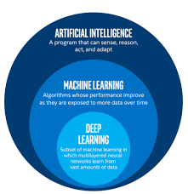
Machine Learning is a part of Artificial Intelligence that focuses on the study of computing and mathematical algorithms and data sets to make decisions without writing manual code. In other words, machine learning is writing code that lets machines make decisions based on pre-defined algorithms on provided datasets.

Q.2. Explain decision tree ?
Ans. A decision tree is a diagram or chart that people use to determine a course of action or show a statistical probability. It forms the outline of the namesake woody plant, usually upright but sometimes lying on its side. Each branch of the decision tree represents a possible decision, outcome, or reaction. The farthest branches on the tree represent the end results.
A decision tree is a graphical depiction of a decision and every potential outcome or result of making that decision. Individuals deploy decision trees in a variety of situations, from something simple and personal ("Should I go out for dinner?") to more complex industrial, scientific or microeconomic undertakings.
By displaying a sequence of steps, decision trees give people an effective and easy way to visualize and understand the potential options of a decision and its range of possible outcomes. The decision tree also helps people identify every potential option and weigh each course of action against the risks and rewards each option can yield.
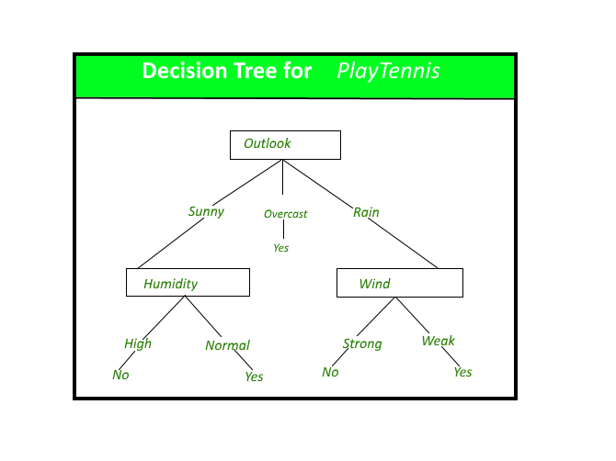
In the decision tree, each end result has an assigned risk and reward weight or number. If a person uses a decision tree to make a decision, they look at each final outcome and assess the benefits and drawbacks. The tree itself can span as long or as short as needed in order to come to a proper conclusion.
A decision tree is a graphical depiction of a decision and every potential outcome or result of making that decision. Individuals deploy decision trees in a variety of situations, from something simple and personal ("Should I go out for dinner?") to more complex industrial, scientific or microeconomic undertakings.
Q.3. Explain logistic regression ?
Ans. This refers to a regression model that is used for classification.
- This method is widely used for binary classification problems. It can also be extended to multi-class classification problems.
- Here, the dependent variable is categorical: y ϵ {0, 1}
- A binary dependent variable can have only two values, like 0 or 1, win or lose, pass or fail, healthy or sick, etc
- In this case, you model the probability distribution of output y as 1 or 0. This is called the sigmoid probability (σ).
- If σ(θ Tx) > 0.5, set y = 1, else set y = 0
- Unlike Linear Regression (and its Normal Equation solution), there is no closed form solution for finding optimal weights of Logistic Regression. Instead, you must solve this with maximum likelihood estimation (a probability model to detect the maximum likelihood of something happening).
- It can be used to calculate the probability of a given outcome in a binary model, like the probability of being classified as sick or passing an exam.
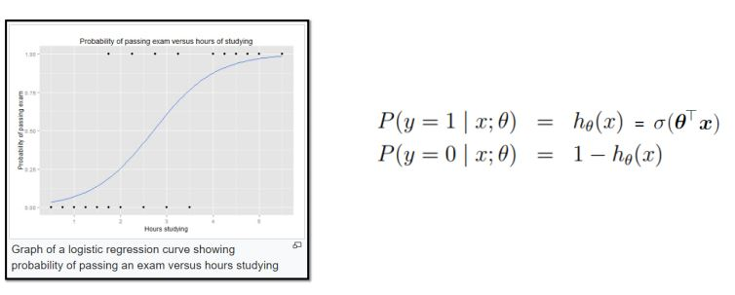

Sigmoid Probability
- The probability in the logistic regression is often represented by the Sigmoid function (also called the logistic function or the S-curve):
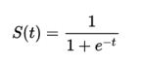
- In this equation, t represents data values * the number of hours studied and S(t) represents the probability of passing the exam.
- Assume sigmoid function:
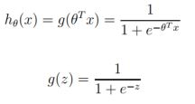
- g(z) tends toward 1 as z -> infinity , and g(z) tends toward 0 as z -> infinity

